“Trump’s Victory”
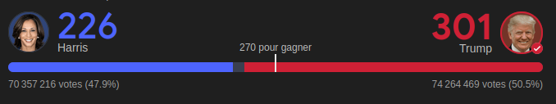
Source : Google

Trump’s Win Is Likely to Prolong Gaza Talks Uncertainty
The New York Times, 07th November of 2024
Any progress toward a cease-fire could be halted due to Trump's election.
Mr. Trump told supporters in his victory speech. “I’m going to stop wars.”
On the first hand, the situation is not clear about what is going to happened but Michael Stephens, a Middle East expert at the Royal United Services Institute said that the Prime Minister Benjamin Netanyahu of Israel “was waiting for the results of the U.S. presidential election to make a move”.
But on the other hand, more than 43,000 people have been killed in Gaza since the war began, including thousands of women and children. Gazans are skeptical about what Mr. Trump would do to improve their situation.
https://www.nytimes.com/2024/11/07/world/middleeast/trump-israel-gaza-ceasefire-talks.html

